c.v.

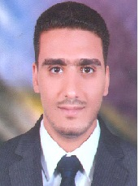
Personal Data

Name: | Ahmed Gamal Eldin Mohamed
Date and Place of Birth: | 15/3/1987, Assiut-Egypt
Nationality: | Egyptian
Institute: | Chemistry Department, Faculty of Science, Assiut University, Assuit, 71516 Egypt
Telephone: | 00201093329868 (Mobil)
Current Position: | Demonstrator
Marital status: | Married
Fields of Research: | Physical Chemistry
E-mail: | ahmedgam@science.au.edu.eg

Education and Academic Qualifications:

2008 : Bachelor of Chemistry, Faculty of Science, Assiut University, Very good with honour grade (82.25%).
2010 until present: Demonstrator, Chemistry Department, Faculty of Science, Assiut University.

